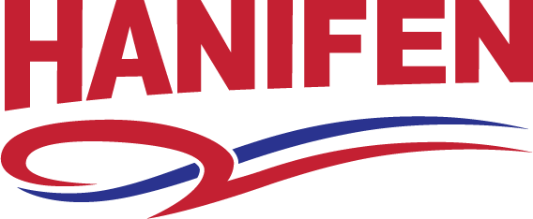

Title: Light Duty Flatbed Tow Truck Operator
Hanifen Towing is a leading regional towing and recovery service in Des Moines, IA. Our company’s focus is on providing outstanding service to our customers. We are currently seeking professional light duty tow truck drivers to join our existing team. These positions are located in Des Moines, IA.
All drivers are home daily!
Some of the basic responsibilities include but are not limited to:
- Safely operate Commercial Motor Vehicle on Public Highways.
- Communicate with the dispatchers in the office.
- Safely and effectively tow vehicles from pickup location to destination, along with any other recovery, contract, or private tow trips that are dispatched.
Some of the basic Skills and Qualifications for the position are:
- Must have a valid Iowa driver’s license, Class A or B CDL with Air Brakes.
- Clean Motor Vehicle Record (MVR) and ability to lift up to 50 lbs. frequently, 75 lbs. occasionally.
- Must be able to work a flexible schedule.
- Arrive to work on time to begin the work day.
- Show up to work wearing the proper company uniform as outlined in the Company Handbook.
- While in a Company truck display safe and professional driving skills.
- Perform shop duties; include but not limited to, cleaning, servicing, and washing trucks, etc.
- Exhibit professional customer service skills.
- Show flexibility and adaptability with the job. This includes availability to work nights and/or weekends for an on-call basis or in emergency situations.
- Must have a current Medical Card.
- A pre-employment and random Drug and Alcohol Testing will be completed.
- Prior driving experience is preferred but not required.
- Must own a smart phone with Bluetooth capabilities, along with a Bluetooth headset for safety reasons.
Hanifen Towing offers competitive pay and a benefit package including;
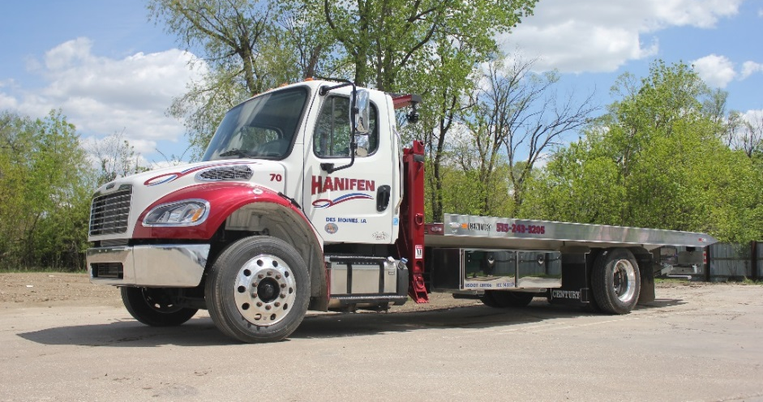
- Paid Time Off
- Medical and Dental Insurance
- Life
- Retirement
Job Type: Full-time

Hanifen Towing
5329 NW 2nd Street, Des Moines, IA
515-243-3205 - - www.hanifentowing.com

